Sharingo

Feasibility Analysis
ENT 320 P

Brett Wright
Kasey Allison
Lyan Almasoud

Table of Contents

Executive Summary 2
Value Proposition 3
Industry Analysis 4
Competitive Analysis 6
Market Analysis 8
Management Team Feasibility 14
Economic Analysis 15
Timeline 17
Appendix 17
Bibliography 18

Executive Summary

In a more global society, people are demanding products from other parts of the world that are exclusive to those countries. These customers experience different products when traveling, and continue to demand them when returning back to their home countries. Residents of Saudi Arabia may come to the U.S. to study abroad, and do not have access to familiar Saudi products when overseas (or vice versa).
Our concept is a mobile application that connects these customers with people traveling abroad who can access those products. This consumer-to-consumer network allows travelers to make easy money while providing international products to people who otherwise can’t access them.

The industry we are operating in is global courier and delivery services in the U.S., a growing $100b industry dominated by key players FedEx and UPS. Our business model takes a unique approach of bringing the shared economy to the delivery industry, relying on consumer acquisition and delivery, and eliminating the transportation infrastructure needed to operate in this industry. As a result, our competition is refocused more towards other similar ecommerce and online marketplaces such as Boutiqaat and MRSOOL.

Our target market consists of students and travelers from Saudi Arabia studying in the U.S. as well as Saudi Arabia residents who may want U.S. products. There are 55,000 Saudi students who come to the United States on scholarships every year and are offered free tickets by their sponsors, and Saudi Arabia has a total population of 34 million.

Our company will experience fast growth because the inflow of students is not likely to go down in the near future and offering them a side hustle will attract most of them to become our working travelers. More often than not, people tend to be attracted by whatever product or service that has not been available to them and their desire for it increases with time. This is the reason we have created an app where we can provide access to these products for clients without them having to travel distances, and in turn benefitting those students who will be using the app to work. Our company will work in collaboration with students, who will be our major stakeholders in delivery of products purchased.

The company will earn its profit from the students using the app, who will in turn benefit from the products they deliver to our clients. We are confident about building an unlimited potential profitable business since we are trying to help people receive products that they really need and are not within their reach.

Financially, we will need approximately $234,735 to start Sharingo and sustain it for one year. We will get this money through both friends and family as well as an angel investor from Saudi Arabia.

We have determined that due to the size of the market, the profitability of the industry, the unfulfilled need in our target market, and the inexpensive operating nature of mobile application businesses (after startup costs) that this venture is feasible and scalable. Once this model is proven, it can be expanded.

Value Proposition

Sharingo aims to provide both access to American products for Saudi Arabian residents and a reminder of the time spent overseas for former travelers. Many products are exclusively sold in certain countries and cannot be purchased overseas. This customer group is used to access to a wide variety of products unavailable in Saudi Arabia and we aim to provide a channel between the consumers abroad and the products available here (and vice versa). As a result, students from Saudi Arabia studying abroad in the United States benefit from the ability to obtain familiar products from home in an unfamiliar place.
Our proposed solution is an application service that connects international travelers with Saudi Arabians residing nearby. Customers can request delivery of a foreign product and travelers can accept the job. The two parties individually negotiate a price that incorporates the traveler’s upcharge that suits both parties. The traveler would then pick up the product when overseas and deliver it to the customer upon return. The traveler keeps the margin between the negotiated price that the customer paid and the price they paid for it abroad.
This service creates two potential benefits, for the consumers and the travelers. The primary benefit is for consumers residing in Saudi Arabia to access products from abroad not available through traditional marketplaces. This is an emotional benefit, not easily quantifiable. The secondary benefit is for travelers to make money by acquiring products abroad and delivering them to people in their area for a negotiated price. (Pricing and purchasing occurs through our platform). This is a source of income for the traveler and it’s an easily quantifiable benefit that our platform can track.
The message we will convey to our target audience is to live beyond the limits of their own country. We want people to be able to have access to any products they desire regardless of whether or not it is available near them geographically.

Industry Analysis

Our industry is Courier and Local Delivery Services in the U.S. (NAICS code 49222). This industry’s activities mainly consist of air and land delivery services, mail and parcel delivery, food delivery, and messenger services. Courier services and messengers operate by establishing a network to transport goods between supplier and consumer. This is the most accurate industry our business will operate in, however Shaingo takes a consumer-to-consumer approach to product acquisition and delivery. Key economic drivers in this industry include corporate profit, ecommerce sales, consumer spending, and number of businesses in operation. Other indirect drivers include oil prices and international politics, because oil changes the cost of transportation and politics and policy can influence the relationships between countries these businesses operate in.
The Courier and Delivery industry in the U.S. crossed $10.8 billion in profit on $100.5b in revenue in 2018, with anticipated growth of 4.6% over the next five years. Annual employment wages reached $32.7b in 2018.
As displayed in the following table, not only has revenue crossed $100b for the first time in 2018, but the rate of growth continues to increase annually. Online marketplaces and increased globalization (along with overseas manufacturing) have provided steady growth for the industry.
Profit margins industry-wide account for approximately 10.7% of total revenue in 2018 (up from 9.5% in 2013). This shows steady growth in profit margins as the industry grows (economies of scale) and becomes more efficient. Advancing technologies and improved efficiency in travel, shipping, and distribution have reduced costs in the industry, improving margins and growing existing competitors.

Year | Revenue $ million | Growth %
2013 | 81,554.80 | 1.5
2014 | 84,118.30 | 3.1
2015 | 86,851.00 | 3.2
2016 | 90,798.80 | 4.5
2017 | 93,952.80 | 3.5
2018 | 100,547.80 | 7.0
(IBISWorld 2019)
This data above shows that the industry, although specified as “mature”, is still experiencing growth. The growth in this industry is influenced by a number of outside drivers, including increasing ecommerce sales, dropping oil prices, and increasing consumer spending and consumer confidence. Globalization in the industry is increasing, with market share being dominated by two large shipping companies (UPS, FedEx) with smaller delivery services and messengers becoming obsolete.
Barriers to entry are medium in this industry, and our business model avoids some of these barriers. On a global scale, barriers to entry are higher than local because of the transportation and infrastructure necessary to acquire, transport, and deliver packages. Our niche strategy relies upon consumer-to-consumer delivery and procurement, so this barrier is negligible.

- Supply-side economies of scale aren’t traditionally associated with this industry, due to infrastructure and transportation costs rising with the volume of packages a courier transports. Our business model does not encompass these costs, and as a medium between supplier and consumer, our model does not have costs that are relative to scale other than data storage and mobile app capabilities to support a higher quantity of users.
- Demand-side benefits of scale are an issue, because consumers will be willing to pay a higher price for a reliable, large, proven incumbent. Our untested business model needs to prove its effectiveness and efficiency to overcome this barrier.
- Since customers will be acquiring familiar products through our service, the only potential customer switching cost is an increase in price due to negotiable pricing between customer and traveler.
- Due to our shared economy business model through our mobile app, capital requirements are not a barrier to entry when compared to other incumbents in the industry.
- There are incumbency advantages independent of size. Saudi Arabians in the U.S. may trust their family members to ship goods to them through FedEx, UPS, or other courier services personally rather than a new platform that relies on a stranger to acquire and deliver the good for them. Proven companies are more trustworthy.
- Unequal access to distribution channels is not a barrier to entry, because our business is the distribution channel. Our model eliminates the need to develop physical transportation infrastructure.
The Express Carriers Association exists to foster relationships between couriers worldwide. Carriers, shippers, and vendors are all welcome to apply to register, with the goal of assisting carriers with utilizing new technology, building awareness of members’ new products, and providing necessary tools for members in different areas of the distribution chain to create logistical partnerships. Annual dues for this association are $695.

Competitive Analysis

It’s difficult to estimate a precise number of competitors in ecommerce (a highly saturated market with new entrants emerging regularly).
The number of competitors is growing since our economy is becoming more global and the internet provides users with the opportunity of starting an ecommerce business.
However, the global courier side of our business model only has two primary competitors (UPS, FedEz) and is not experiencing the same influx of competitors as the ecommerce side, and our business model is unique among competitors in this market.
The following is a list of direct competitors that appeal to our target market with a similar value proposition:

Boutiqaat
It is undeniable that the global market will have competition. Some companies that already exist include Boutiqaat and MarSool who are operating in Saudi Arabia and Kuwait. Boutiqaat is an e-commerce platform which incorporates Arab celebrities and social media influencers who recommend products allowing consumers to shop directly from these influencers’ virtual stores inside Boutiqaat. The advantage of using boutiqaat is that it allows the followers to seamlessly connect with their favorite celebrities, makeup gurus and influencers providing them unlimited access to the industry’s latest trends. However, the products is almost double the price of the original. My team and I have concluded Boutiqaat charge up to 47% higher than the original cost on average and 9 dollar flat fee which is similar to our proposal.

Marsool
On the other hand, Marsool is the second emerging company which has grown rapidly over the past few years. By the time it closed series A in early 2019, the on-demand delivery platform has processed over 1 billion Riyals, serving over 4 million users across all the cities of the Saudi kingdom. This pioneered platform is very similar to our business concept which is the on-demand service fulfillment model in the region, by establishing a massive customer-to-customer network through a generic chat-based ordering experience, allowing users to be creative and unconstrained in describing the service needed, and giving the couriers the option to bid with their price they see fit which is a flat fee of 20%, ensuring a fully scalable and self-regulating model.

Marsool’s revenue stream is similar to our proposal. They charge a $9 flat fee per transaction.

Indirect competitors in ecommerce include global online marketplaces such as Amazon, eBay, and Alibaba. These competitors operate on a larger and broader scale than our proposed venture and don’t offer all of the region-specific products our target market desires. These competitors have large costs due to their established distribution. networks, while we propose a consumer-to-consumer exchange that eliminates the need for such infrastructure.
Indirect competitors in the global courier and delivery services industry include UPS and FedEx, who dominate the market. As they do not offer the same storefront opportunities our application presents, they are not direct competitors. The products customers desire still have to be purchased elsewhere before they can be shipped through these competitors.

Market Analysis

With increased multicultural communities and globalization, demand for products from different parts of the world has become a common norm. Individuals travelling to and from different countries have expressed their desire for some of the products they have come across when travelling because most of them are not available in their home countries, or they are of good quality compared to what is readily available to them. This analysis presents our idea of venturing into the global market by creating awareness of the industry of operation, evaluation of the target market and competitors while offering sufficient prove that our idea is feasible.

We have one primary target markets for this proposed venture. It will be international students from Saudi Arabia who are studying in the United States. These could be undergraduate or grad students who will be returning to Saudi Arabia after they are finished studying. This group will be both the customers requesting products and the travelers accepting requests, picking up products, and delivering them back to the U.S.
The following is a list of demographics of our primary target market (Saudi Arabian residents studying abroad in the U.S.):
- Market Size: 55,000 (2018)
- Age: 18-30
- Gender: Male and Female
- Race: Middle Eastern, Saudi Arabian
- Religion: Muslim
- Income: Middle-Upper class, avg. 54,770 USD.
We can expect to draw users from all over Saudi Arabia. In terms of U.S. geography, these users will be located nationwide in urban areas. These urban areas typically have universities with international/foreign exchange programs, where Saudi Arabian students will be studying.
The population of Saudi Arabia is steadily increasing every year and is currently around 34 million. The population growth rate has varied between 1% and 7% every year since 1960. This constant population increase will give Sharingo more of an opportunity to become a popular business in the country. More residents means more potential customers.

There were over 120,000 Saudi Arabian students that came to the United States to study in 2015 which was the highest it's ever been. In 2016, that number greatly decreased because the kingdom scaled back the study abroad scholarship program. In addition to a reduced amount of scholarships available, many students interested in studying abroad reported feeling unsafe going to the United States due to social events and the political climate. Last year, approximately 55,000 students from Saudi Arabia came to study in the United States.

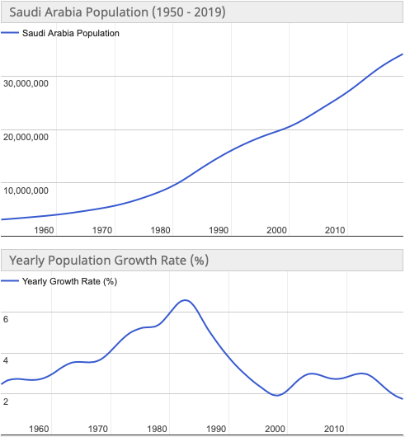

Saudi Arabian students who travel to the United States to study are typically the age of average college students, between 18-30 years old. The median age of the total population in Saudi Arabia is 30.2 years old. About 26% of the population is 0-14 years old, 19% is 15-24 y.o., 47% is 25-54, 5% is 55-64 years old, and 3% is over age 65.
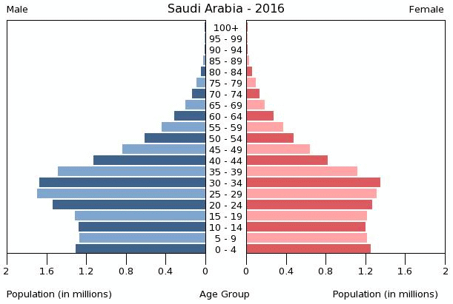

Traveling students from Saudi Arabia are usually on a scholarship and do not hold jobs, and therefore do not have a normal income. The gross national income per capita in Saudi Arabia is approximately $54,770 purchasing power parity.

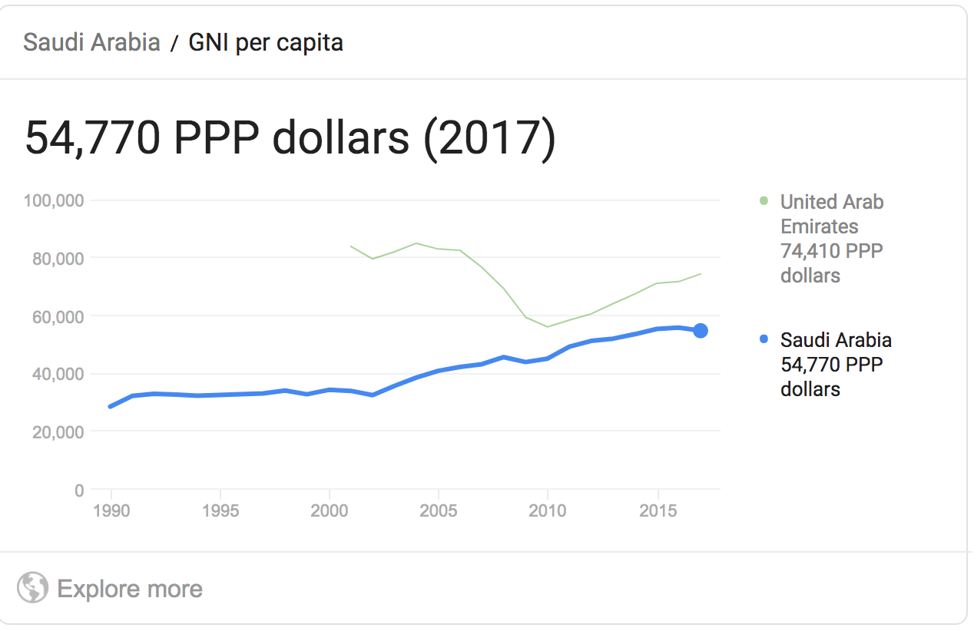

Our target market is a niche strategy, but there is sufficient demand to create a profitable venture.
Saudi Arabian students have scholarships and receive a salary of $1800 each month. All students receive the same salary regardless which U.S. state they live in. Most of the Saudi students spend majority of their salary on their rent and utilities leaving just a small amount for food. A lot of Saudi students also request money from their parents to financially support them through their journey. We have concluded through our survey that 60% of Saudi Arabians have found it difficult to acquire products from the U.S when in Saudi Arabia and 90% have asked someone to get them a product from the U.S at least once in their lifetime. The app will be a solution to both the pain of the Saudi students living in the states with financial burden on their back and Saudis living in Saudi Arabia with the desire of acquiring an inaccessible product. We believe the app will be successful because of the ease of use and the financial benefit for these students. With the free ticket provided by the Saudi embassy to visit back home every year, the student will be appealed and have nothing to lose to deliver the product back home.
Below are the visuals portraying our survey results.
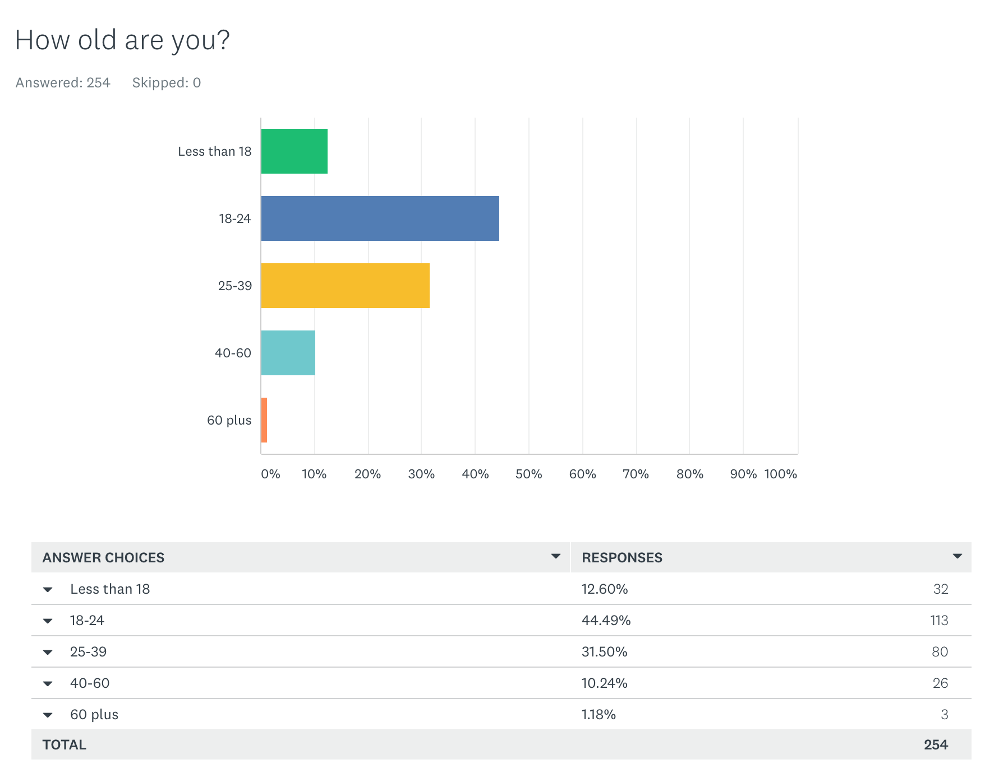
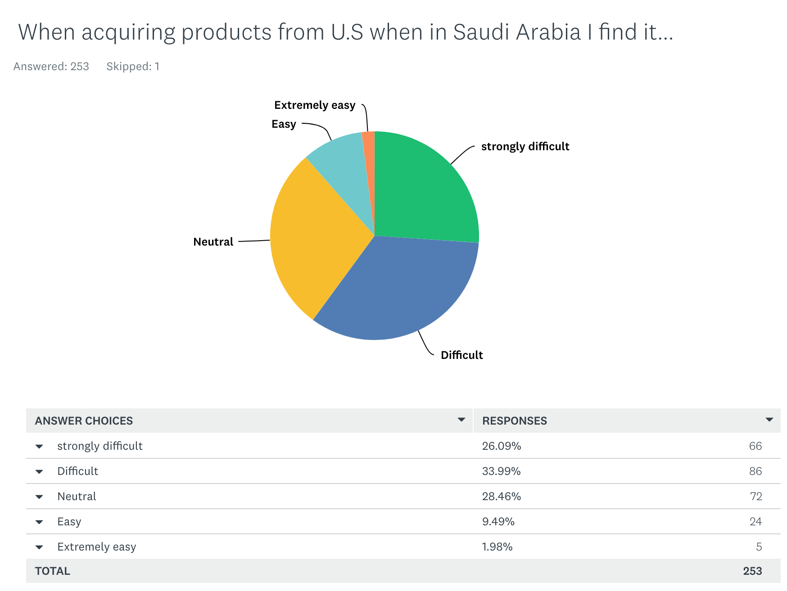
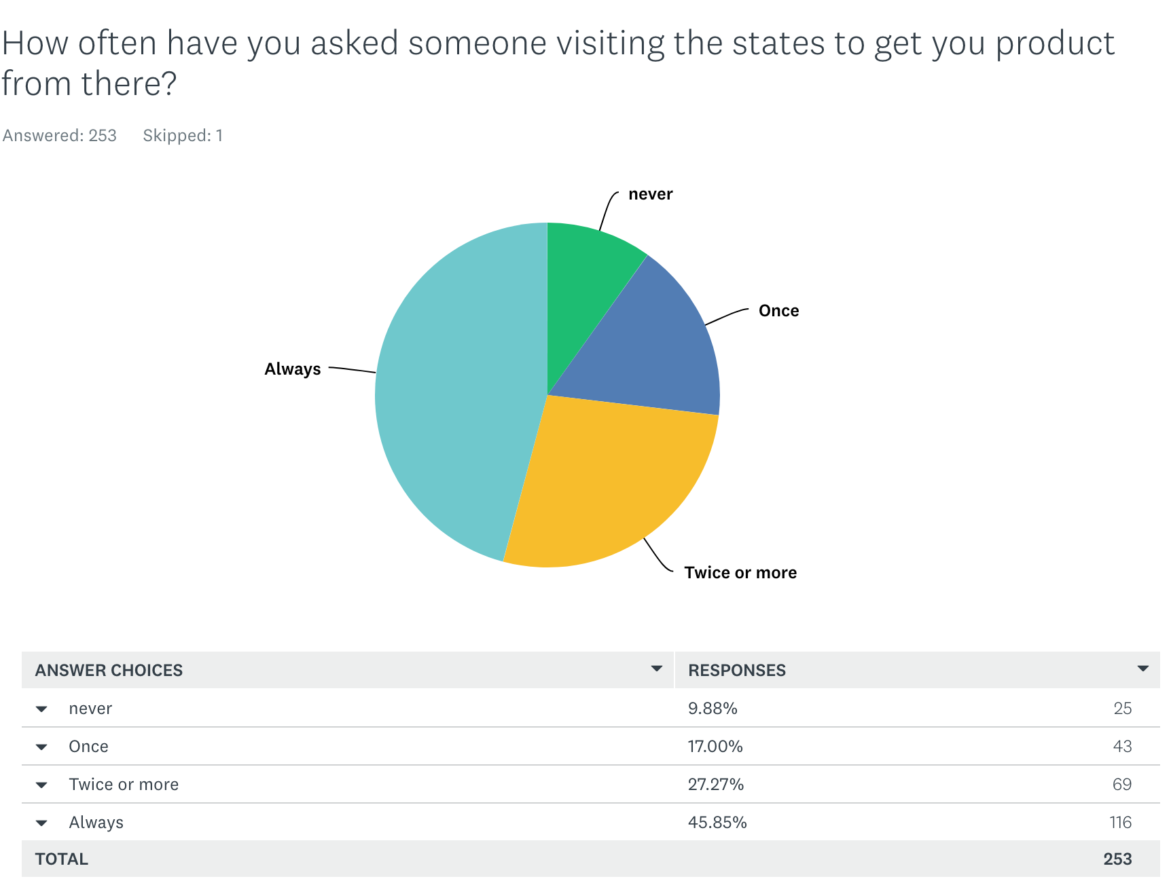
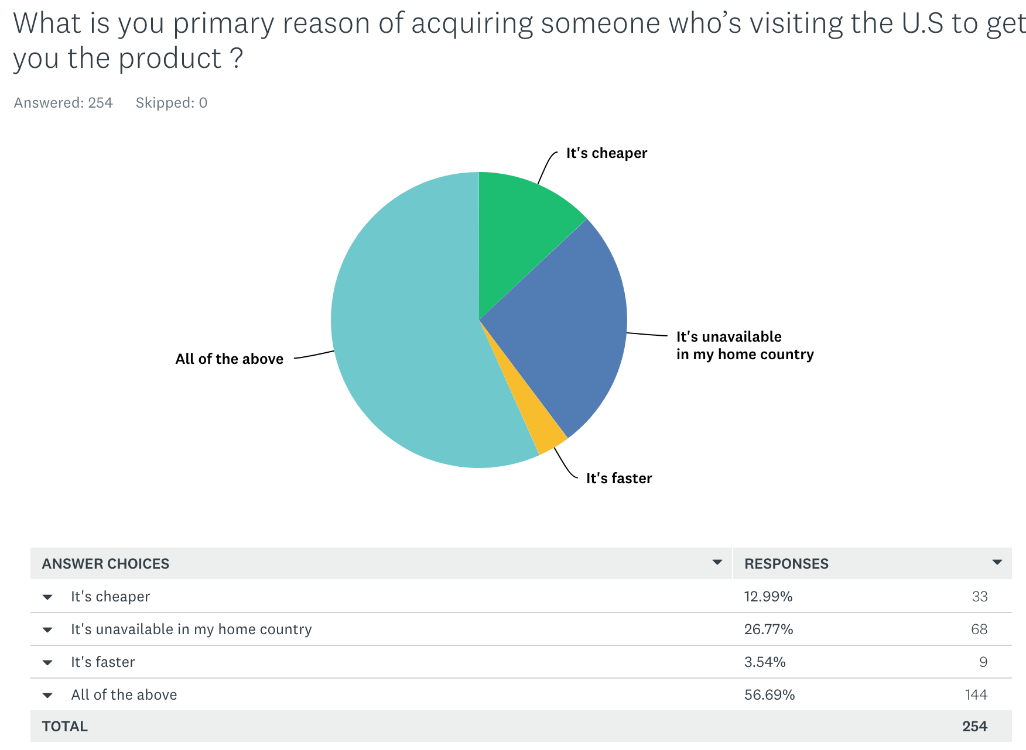
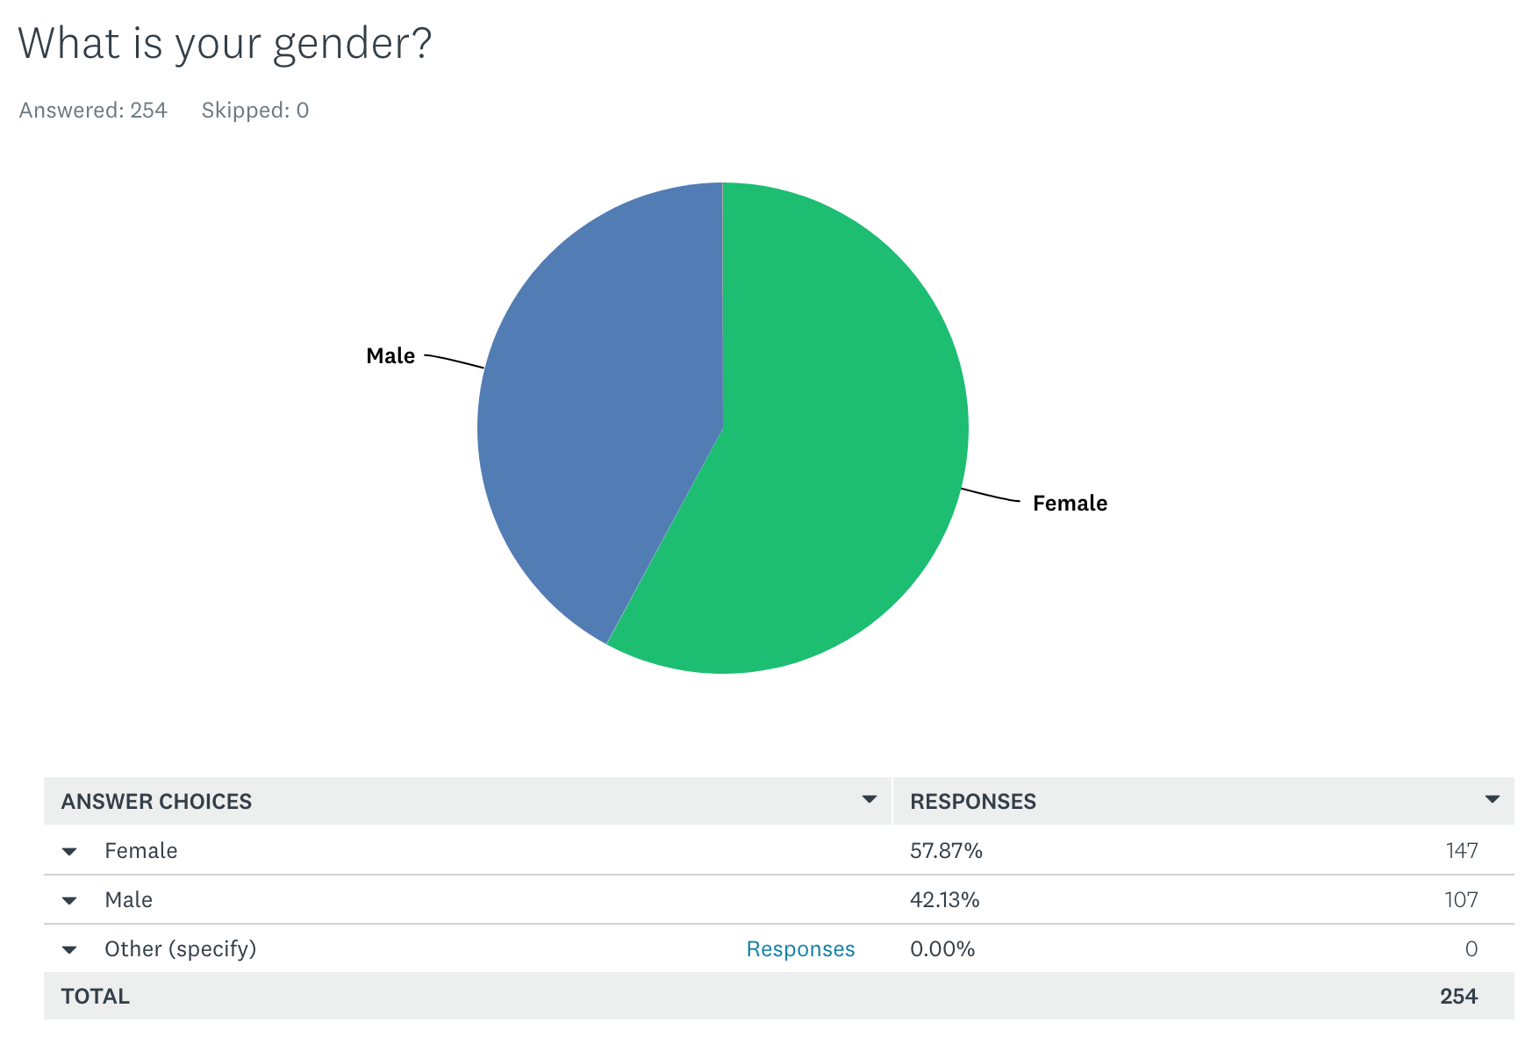

Management Team Feasibility

We will definitely need strong communication skills mostly over the phone and in written form. Since we are an online business, there will not be much face to face interaction with customers. We will also need cultural expertise since we are dealing with countries that are very different from each other. We will need to know the appropriate ways to talk to people from different cultures, specifically American and Saudi Arabian cultures. We will also need expertise in app development to create our application.
One of our team members, Lyan Almasoud, a finance and entrepreneurship major is a student from Saudi Arabia who has been living in the states since 2014. She received a scholarship from her embassy back in 2018 and have delivered many products for her family and friends without gaining getting any financial benefits. Lyan is the member who originally developed the idea.
Our two other members of the founding team, Kasey Allison and Brett Wright, are marketing majors with expertise in sales, promotions, marketing, and branding.
Our team does not have expertise in app or software development. In order to develop the application and website we will be using an outsourced developer.

Economic Analysis

Our business model is exciting and complex. It offers not only the opportunity for Sharingo to generate revenue, but also for users to make money from their travels. The company will make revenue through a flat fee with each transaction. When a consumer matches with a traveler, and they agree on their price, our $8.00 fee will be added onto this cost. The traveler will also receive a commission as well, part of the negotiated price between consumer and traveler (with the commission being the difference between the negotiated price and the purchase price while abroad).
Our main objective is to understand what Saudi residents require that is not available in the U.S and vice versa. We want to be a company that is fully networked with its clients through generic chats, which allow them to give clear descriptions of the needed product. Additionally, our target markets assure us of receiving clients at any given time, whether the schools are on or closed because we are focusing on individuals in Saudi Arabia and those in the United States.
As detailed in our Appendix, total start-up capital equals out to $234,735. This number was generated with the plan to develop an initial minimum viable product, while spending more later in the first year of operations after our initial launch to develop a better platform and solve any issues from the initial product.
Sharingo will be mostly seasonal because it is based around when international students are traveling between school in the United States and home in Saudi Arabia. There are annual breaks meant for travel in December for the Holidays, as well as in May for the Summer. These will be the busy times for Sharingo although it will still be possible for people to use our application other times of the year if wanted.

There are approximately 6.7 million Saudi Arabian residents in our target market of 18-30 year olds. We found in a survey that 90% of them have wanted another person to pick up a product for them in the united states and about 60% of them find it difficult or extremely difficult to acquire the desired product. These leaves about 3.6 million people who would potentially be interested in using out application service. Since when we are starting out, our business will not be as well known, we are not expecting all of these people to be customers in our first year but this shows that there will at least be enough customer demand to start our business.
Of the 55,000 Saudi Arabian students coming to the United States to study, we are expecting about 12,000 of them to be interested in being involved as a traveler in a business like this. Considering they travel back home twice a year, once for Winter break and once for Summer break, we are expecting 24,000 transactions in our first year. At $8 per transaction, our estimated first year sales would come to $192,000.
Our gross margin will be the same as our estimated sales since we do not have to pay any additional costs to manufacture any physical products.
We are a service company so we do not have any variable costs so our breakeven costs will just be fixed costs/price. Our Start up costs are $234,734 and our price is $8 so the number of transactions it will take to breakeven is 29,342. This means it will take just over a year to breakeven.

Conditions and trends that can change our estimates are large-scale issues, more specifically the political and economic relationship between Saudi Arabia and the United States. Less Saudi students are studying in the U.S. today than several years ago because of a sour political climate and the powers in the U.S. has discouraged travel to the U.S. from predominantly muslim nations.

Riyadh-based on-demand delivery startup Mrsool has raised a multi-million (US Dollar) Series A round led by MENA’s largest VC fund Saudi Technology Ventures (STV) and Raed Ventures, STV announced today, adding that Saudi angel investor Mazen Al Jubeir also joined the round.

“Consumers are becoming increasingly accustomed to the convenience of instantaneous delivery of goods. We believe the offline-to-online shift in the global delivery market will be even more amplified in the MENA region, supported by extremely high mobile penetration rates in markets like Saudi and the UAE,” Dr. Enaya added. Saudi has a high mobile subscription with over 93%. The startup processed orders worth more than $267 million dollar last year though they launched only 2 years ago. Though it's hard to estimate outside sources amount. I believe partnering with STV or Raed ventures will increase the adoption of digital and mobile commerce when we later expand in Gulf Cooperation Council (GCC) which they will be helping with crowdsourcing delivery by matching shoppers with couriers from all around the arab gulf.

Timeline

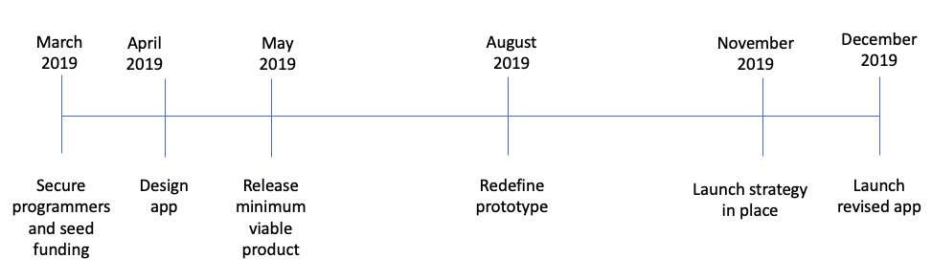

Appendix

List of expenses for 1 year:
- Rent $12,000
- Insurance $425
- Utilities $12,000
- Apple App Store Fee $99
- Google Play Store Fee $25
- Management Salary $120,000

Start-up Costs
Facilities | Total Cost
Rent + Deposit (prior to opening) | $12,000
Utility Deposits | $12,000
Marketing
Website/app Design | $40,000
Domain | $10
Social Media Budget (or other) | $50,000
Opening Costs
Management Salary | $120,000
Fees and Other Costs
Legal Consultation | $300
Insurance Fees | $425
Total Start-up Costs | $234,735

Bibliography

“Express Carriers Association.” Express Carriers Association, ECA, expresscarriers.org/.

“Online Shopping for Women in Kuwait | Buy Beauty, Cosmetics, Fragrances & More.” Boutiqaat, www.boutiqaat.com/en-kw/.

“Mrsool Completes Series A Funding Led by STV and Raed Ventures.” Arabnet, www.arabnet.me/english/editorials/entrepreneurship/investment/mrsool-series-a-stv-raed.

“Investments Archives.” Raed Ventures, raed.vc/category/investments/.
Kalyani, Darshan. “IBISWorld Industry Report 49222 - Couriers & Local Delivery Services in the US.” IBISWorld US, IBISWorld, Jan. 2019, clients1-ibisworld-com.esearch.ut.edu/reports/us/industry/default.aspx?entid=1950.

“Saudi Arabia Age Structure.” Saudi Arabia Age Structure - Demographics, www.indexmundi.com/saudi_arabia/age_structure.html.

“Saudi Arabia Population (LIVE).” Worldometers, www.worldometers.info/world-population/saudi-arabia-population/.

“Saudi Arabia.” U.S. Department of State, U.S. Department of State, 7 Aug. 2018, www.state.gov/r/pa/ei/bgn/3584.htm.

“Saudi Ties to U.S. Colleges Come under Mounting Scrutiny.” Tampa Bay Times, 30 Oct. 2018, www.tampabay.com/news/nationworld/saudi-ties-to-us-colleges-come-under-mounting-scrutiny-20181030/.

Sawahel, Wagdy. “Many Arab Students Go to the U.S., But Rarely Is the Reverse True.” The Chronicle of Higher Education, The Chronicle of Higher Education, 6 Jan. 2016, www.chronicle.com/article/Many-Arab-Students-Go-to-the/234818

“US Colleges Attracting Fewer New Students from Abroad.” CNBC, CNBC, 13 Nov. 2018, www.cnbc.com/2018/11/13/us-colleges-attracting-fewer-new-students-from-abroad.html.

End-User License Agreement
“Terms of Use”

Last updated: May 3rd, 2019

Please read this End-User License Agreement ("Agreement") carefully before clicking the "I Agree" button, downloading or using Sharingo .

By clicking the "I Agree" button, downloading or using the Application, you are agreeing to be bound by the terms and conditions of this Agreement.

If you do not agree to the terms of this Agreement, do not click on the "I Agree" button and do not download or use the Application.

License

Sharingo grants you a revocable, non-exclusive, non-transferable, limited license to download, install and use the Application solely for your personal, non-commercial purposes strictly in accordance with the terms of this Agreement.

Restrictions

You agree not to, and you will not permit others to:

a) license, sell, rent, lease, assign, distribute, transmit, host, outsource, disclose or otherwise commercially exploit the Application or make the Application available to any third party.

Modifications to Application

Sharingo reserves the right to modify, suspend or discontinue, temporarily or permanently, the Application or any service to which it connects, with or without notice and without liability to you.

Term and Termination

This Agreement shall remain in effect until terminated by you or Sharingo.

Sharingo may, in its sole discretion, at any time and for any or no reason, suspend or terminate this Agreement with or without prior notice.

This Agreement will terminate immediately, without prior notice from Sharingo, in the event that you fail to comply with any provision of this Agreement. You may also terminate this Agreement by deleting the Application and all copies thereof from your mobile device or from your desktop.

Upon termination of this Agreement, you shall cease all use of the Application and delete all copies of the Application from your mobile device or from your desktop.

Severability

If any provision of this Agreement is held to be unenforceable or invalid, such provision will be changed and interpreted to accomplish the objectives of such provision to the greatest extent possible under applicable law and the remaining provisions will continue in full force and effect.

Amendments to this Agreement

Sharingo reserves the right, at its sole discretion, to modify or replace this Agreement at any time. If a revision is material we will provide at least 30 days' notice prior to any new terms taking effect. What constitutes a material change will be determined at our sole discretion.

Contact Information

If you have any questions about this Agreement, please contact us.

